Module-6
Network layer Functions and Protocols

Routing
- Routing is a process that is performed by layer 3 (or network layer) devices in order to deliver the packet by choosing an optimal path from one network to another.
- A Routing is a process of selecting path along which the data can be transferred from source to the destination. Routing is performed by a special device known as a router.
- A Router works at the network layer in the OSI model and internet layer in TCP/IP model
- A router is a networking device that forwards the packet based on the information available in the packet header and forwarding table.
- The routing algorithms are used for routing the packets. The routing algorithm is nothing but a software responsible for deciding the optimal path through which packet can be transmitted.
- The routing protocols use the metric to determine the best path for the packet delivery. The metric is the standard of measurement such as hop count, bandwidth, delay, current load on the path, etc. used by the routing algorithm to determine the optimal path to the destination.
- The routing algorithm initializes and maintains the routing table for the process of path determination.

Routing Metrics and Costs
Routing metrics and costs are used for determining the best route to the destination. The factors used by the protocols to determine the shortest path, these factors are known as a metric.
Metrics are the network variables used to determine the best route to the destination. For some protocols use the static metrics means that their value cannot be changed and for some other routing protocols use the dynamic metrics means that their value can be assigned by the system administrator.
The most common metric values are given below:
- Hop count: Hop count is defined as a metric that specifies the number of passes through internetworking devices such as a router, a packet must travel in a route to move from source to the destination. If the routing protocol considers the hop as a primary metric value, then the path with the least hop count will be considered as the best path to move from source to the destination.
- Delay: It is a time taken by the router to process, queue and transmit a datagram to an interface. The protocols use this metric to determine the delay values for all the links along the path end-to-end. The path having the lowest delay value will be considered as the best path.
- Bandwidth: The capacity of the link is known as a bandwidth of the link. The bandwidth is measured in terms of bits per second. The link that has a higher transfer rate like gigabit is preferred over the link that has the lower capacity like 56 kb. The protocol will determine the bandwidth capacity for all the links along the path, and the overall higher bandwidth will be considered as the best route.
- Load: Load refers to the degree to which the network resource such as a router or network link is busy. A Load can be calculated in a variety of ways such as CPU utilization, packets processed per second. If the traffic increases, then the load value will also be increased. The load value changes with respect to the change in the traffic.
- Reliability: Reliability is a metric factor may be composed of a fixed value. It depends on the network links, and its value is measured dynamically. Some networks go down more often than others. After network failure, some network links repaired more easily than other network links. Any reliability factor can be considered for the assignment of reliability ratings, which are generally numeric values assigned by the system administrator.

Types of Routing
Routing can be classified into three categories:
- Static Routing
- Default Routing
- Dynamic Routing
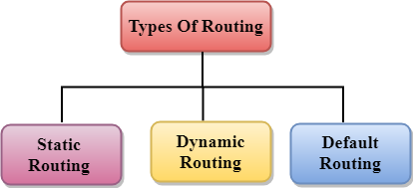

Static Routing
- Static Routing is also known as Nonadaptive Routing.
- It is a technique in which the administrator manually adds the routes in a routing table.
- A Router can send the packets for the destination along the route defined by the administrator.
- In this technique, routing decisions are not made based on the condition or topology of the networks

Advantages Of Static Routing
Following are the advantages of Static Routing:
- No Overhead: It has ho overhead on the CPU usage of the router. Therefore, the cheaper router can be used to obtain static routing.
- Bandwidth: It has not bandwidth usage between the routers.
- Security: It provides security as the system administrator is allowed only to have control over the routing to a particular network.

Disadvantages of Static Routing:
Following are the disadvantages of Static Routing:
- For a large network, it becomes a very difficult task to add each route manually to the routing table.
- The system administrator should have a good knowledge of a topology as he has to add each route manually.

Default Routing
- Default Routing is a technique in which a router is configured to send all the packets to the same hop device, and it doesn't matter whether it belongs to a particular network or not. A Packet is transmitted to the device for which it is configured in default routing.
- Default Routing is used when networks deal with the single exit point.
- It is also useful when the bulk of transmission networks have to transmit the data to the same hp device.
- When a specific route is mentioned in the routing table, the router will choose the specific route rather than the default route. The default route is chosen only when a specific route is not mentioned in the routing table.

Dynamic Routing
- It is also known as Adaptive Routing.
- It is a technique in which a router adds a new route in the routing table for each packet in response to the changes in the condition or topology of the network.
- Dynamic protocols are used to discover the new routes to reach the destination.
- In Dynamic Routing, RIP and OSPF are the protocols used to discover the new routes.
- If any route goes down, then the automatic adjustment will be made to reach the destination.
The Dynamic protocol should have the following features:
- All the routers must have the same dynamic routing protocol in order to exchange the routes.
- If the router discovers any change in the condition or topology, then router broadcast this information to all other routers.

Advantages of Dynamic Routing:
- It is easier to configure.
- It is more effective in selecting the best route in response to the changes in the condition or topology.

Disadvantages of Dynamic Routing:
- It is more expensive in terms of CPU and bandwidth usage.
- It is less secure as compared to default and static routing.

Classification of Routing Algorithms
The routing algorithms can be classified as follows:
- Adaptive Algorithms
- Non-Adaptive Algorithms
- Hybrid Algorithms
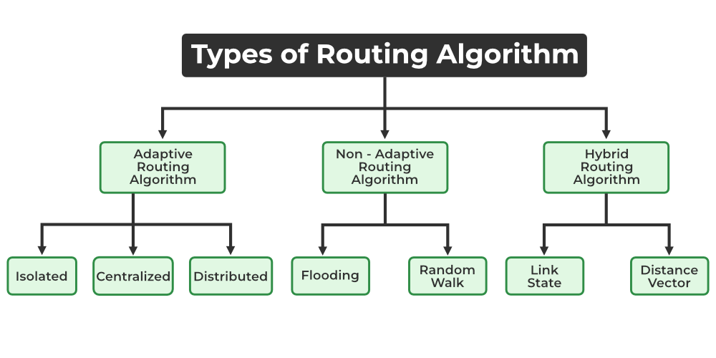

1. Adaptive Algorithms
These are the algorithms that change their routing decisions whenever network topology or traffic load changes. The changes in routing decisions are reflected in the topology as well as the traffic of the network. Also known as dynamic routing, these make use of dynamic information such as current topology, load, delay, etc. to select routes. Optimization parameters are distance, number of hops, and estimated transit time.
Further, these are classified as follows:
- Isolated: In this method each, node makes its routing decisions using the information it has without seeking information from other nodes. The sending nodes don’t have information about the status of a particular link. The disadvantage is that packets may be sent through a congested network which may result in delay. Examples: Hot potato routing, and backward learning.
- Centralized: In this method, a centralized node has entire information about the network and makes all the routing decisions. The advantage of this is only one node is required to keep the information of the entire network and the disadvantage is that if the central node goes down the entire network is done. The link state algorithm is referred to as a centralized algorithm since it is aware of the cost of each link in the network.
- Distributed: In this method, the node receives information from its neighbors and then takes the decision about routing the packets. A disadvantage is that the packet may be delayed if there is a change in between intervals in which it receives information and sends packets. It is also known as a decentralized algorithm as it computes the least-cost path between source and destination.

2. Non-Adaptive Algorithms
These are the algorithms that do not change their routing decisions once they have been selected. This is also known as static routing as a route to be taken is computed in advance and downloaded to routers when a router is booted.
Further, these are classified as follows:
- Flooding: This adapts the technique in which every incoming packet is sent on every outgoing line except from which it arrived. One problem with this is that packets may go in a loop and as a result of which a node may receive duplicate packets. These problems can be overcome with the help of sequence numbers, hop count, and spanning trees.
- Random walk: In this method, packets are sent host by host or node by node to one of its neighbors randomly. This is a highly robust method that is usually implemented by sending packets onto the link which is least queued.
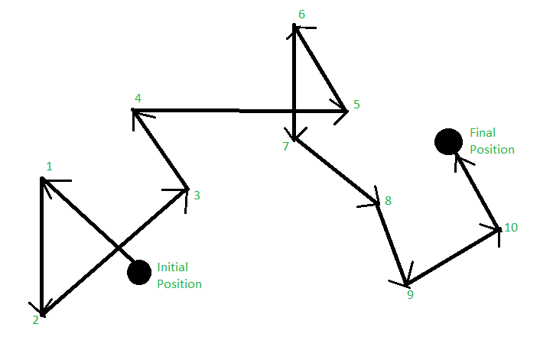
Random Walk

3. Hybrid Algorithms
As the name suggests, these algorithms are a combination of both adaptive and non-adaptive algorithms. In this approach, the network is divided into several regions, and each region uses a different algorithm.
Further, these are classified as follows:
- Link-state: In this method, each router creates a detailed and complete map of the network which is then shared with all other routers. This allows for more accurate and efficient routing decisions to be made.
- Distance vector: In this method, each router maintains a table that contains information about the distance and direction to every other node in the network. This table is then shared with other routers in the network. The disadvantage of this method is that it may lead to routing loops.

Differences between Adaptive and Non-Adaptive Routing Algorithm
Basis Of Comparison | Adaptive Routing algorithm | Non-Adaptive Routing algorithm
Define | Adaptive Routing algorithm is an algorithm that constructs the routing table based on the network conditions. | The Non-Adaptive Routing algorithm is an algorithm that constructs the static table to determine which node to send the packet.
Usage | Adaptive routing algorithm is used by dynamic routing. | The Non-Adaptive Routing algorithm is used by static routing.
Routing decision | Routing decisions are made based on topology and network traffic. | Routing decisions are the static tables.
Categorization | The types of adaptive routing algorithm, are Centralized, isolation and distributed algorithm. | The types of Non Adaptive routing algorithm are flooding and random walks.
Complexity | Adaptive Routing algorithms are more complex. | Non-Adaptive Routing algorithms are simple.

Types of Routing Protocol in Computer Networks

1. Routing information protocol (RIP)
One of the earliest protocols developed is the inner gateway protocol, or RIP. we can use it with local area networks (LANs), that are linked computers in a short range, or wide area networks (WANs), which are telecom networks that cover a big range. Hop counts are used by the Routing Information Protocol (RIP) to calculate the shortest path between networks.

2. Interior gateway protocol (IGRP)
IGRP was developed by the multinational technology corporation Cisco. It makes use of many of the core features of RIP but raises the maximum number of supported hops to 100. It might therefore function better on larger networks. IGRPs are elegant and distance-vector protocols. In order to work, IGRP requires comparisons across indicators such as load, reliability, and network capacity. Additionally, this kind updates automatically when things change, such as the route. This aids in the prevention of routing loops, which are mistakes that result in an unending data transfer cycle.

3. Exterior Gateway Protocol (EGP)
Exterior gateway protocols, such as EGP, are helpful for transferring data or information between several gateway hosts in autonomous systems. In particular, it aids in giving routers the room they need to exchange data between domains, such as the internet.

4. Enhanced interior gateway routing protocol (EIGRP)
This kind is categorised as a classless protocol, inner gateway, and distance vector routing. In order to maximise efficiency, it makes use of the diffusing update method and the dependable transport protocol. A router can use the tables of other routers to obtain information and store it for later use. Every router communicates with its neighbour when something changes so that everyone is aware of which data paths are active. It stops routers from miscommunicating with one another. The only external gateway protocol is called Border Gateway Protocol (BGP).

5. Open shortest path first (OSPF)
OSPF is an inner gateway, link state, and classless protocol that makes use of the shortest path first (SPF) algorithm to guarantee effective data transfer. Multiple databases containing topology tables and details about the network as a whole are maintained by it. The ads, which resemble reports, provide thorough explanations of the path’s length and potential resource requirements. When topology changes, OSPF recalculates paths using the Dijkstra algorithm. In order to guarantee that its data is safe from modifications or network intrusions, it also employs authentication procedures. Using OSPF can be advantageous for both large and small network organisations because to its scalability features.

6. Border gateway protocol (BGP)
Another kind of outer gateway protocol that was first created to take the role of EGP is called BGP. It is also a distance vector protocol since it performs data package transfers using the best path selection technique. BGP defines communication over the internet. The internet is a vast network of interconnected autonomous systems. Every autonomous system has autonomous system number (ASN) that it receives by registering with the Internet Assigned Numbers Authority.

Difference between Routing and Flooding
The difference between Routing and Flooding is listed below:
Routing | Flooding
A routing table is required. | No Routing table is required.
May give the shortest path. | Always gives the shortest path.
Less Reliable. | More Reliable.
Traffic is less. | Traffic is high.
No duplicate packets. | Duplicate packets are present.

Network Protocol
Network Layer is responsible for the transmission of data or communication from one host to another host connected in a network. Rather than describing how data is transferred, it implements the technique for efficient transmission. In order to provide efficient communication protocols are used at the network layer. The data is being grouped into packets or in the case of extremely large data it is divided into smaller sub packets. Each protocol used has specific features and advantages. The below article covers in detail the protocols used at the network layer.

Functions of Network Layer
The network layer is responsible for providing the below-given tasks:
- Logical Addressing: Each device on the network needs to be identified uniquely. Therefore network layer provides an addressing scheme to identify the device. It places the IP address of every sender and the receiver in the header. This header consists of the network ID and host ID of the network.
- Host-to-host Delivery of Data: The network layer ensures that the packet is being delivered successfully from the sender to the receiver. This layer makes sure that the packet reaches the intended recipient only.
- Fragmentation: In order to transmit the larger data from sender to receiver, the network layer fragments it into smaller packets. Fragmentation is required because every node has its own fixed capacity for receiving data.
- Congestion Control: Congestion is defined as a situation where the router is not able to route the packets property which results in aggregation of packets in the network. Congestion occurs when a large amount of packets are flooded in the network. Therefore network layer controls the congestion of data packets in the network.
- Routing and Forwarding: Routing is the process that decides the route for transmission of packets from sender to receiver. It mostly chooses the shortest path between the sender and the receiver. Routing protocols that are mostly used are path vector, distance vector routing, link state routing, etc.

Network Layer Protocols
There are various protocols used in the network layer. Each protocol is used for a different task. Below are the protocols used in the network layer:
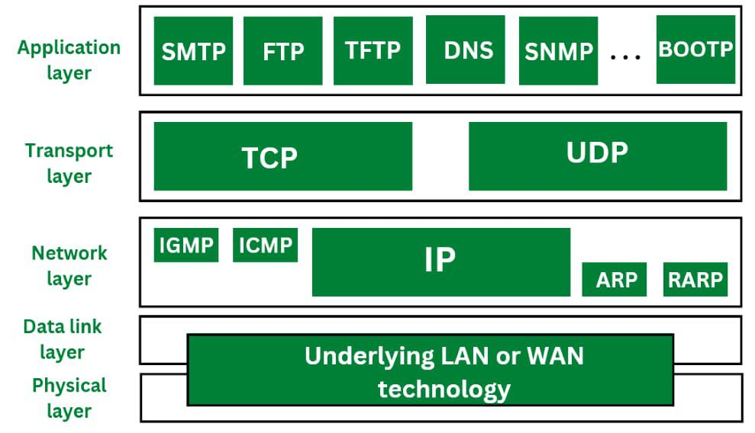
Protocols at each Layer

1. IP (Internet Protocol)
IP stands for Internet Protocol. Internet Protocol helps to uniquely identify each device on the network. Internet protocol is responsible for transferring the data from one node to another node in the network. Internet protocol is a connectionless protocol therefore it does not guarantee the delivery of data. For the successful delivery higher level protocols such as TCP are used to guarantee the data transmission. The Internet Protocol is divided in two types. They are:
- IPv4: IPv4 provides with the 32 bit address scheme. IPv4 addressing has four numeric fields and are separated by dot. IPv4 can be configured either using DHCP or manually. IPv4 does not provide with more security features as it does not support authentication or encryption techniques. IPv4 is further divided into five classes as Class A, Class B, Class C, Class D and Class E.
- IPv6: IPv6 is the most recent version of IP. If provided with a 128 bit addressing scheme. IP address has eight fields that are separated by colon, and these fields are alphanumeric. The IPv6 address is represented in hexadecimal. IPv6 provides with more security features such as authentication and encryption. IPv6 supports end-to-end connection integrity. IPv6 provides with more range of IP address as compared to IPv4.
Question: what are the differences between IPv4 and IPv6: IPv4 vs IPv6

2. ARP (Address Resolution Protocol)
ARP stands for Address Resolution Protocol. ARP is used to convert the logical address ie. IP address into physical address ie. MAC address. While communicating with other nodes, it is necessary to know the MAC address or physical address of the destination node. If any of the node in a network wants to know the physical address of another node in the same network, the host then sends an ARP query packet. This ARP query packet consists of IP address and MAC address of source host and only the IP address of destination host. This ARP packet is then received to every node present in the network. The node with its own IP address recognises it and sends it MAC address to the requesting node. But sending and receiving such packets to know the MAC address of destination node it increases the traffic load. Therefore in order to reduce this traffic and improve the performance, the systems that makes use of ARP maintain a cache of recently acquired IP into MAC address bindings.

How Does ARP Work?
- The host broadcasts an ARP inquiry packet containing the IP address over the network in order to find out the physical address of another computer on its network.
- The ARP packet is received and processed by all hosts on the network; however, only the intended recipient can identify the IP address and reply with the physical address.
- After adding the physical address to the datagram header and cache memory, the host storing the datagram transmits it back to the sender.
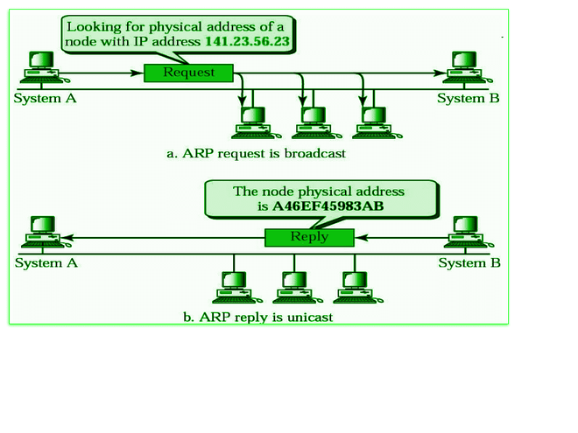
ARP

Types of ARP Entries
- Static Entry: This type of entry is created when a user uses the ARP command utility to manually enter the IP to MAC address association.
- Dynamic Entry: A dynamic entry is one that is automatically formed when a sender broadcasts their message to the whole network. Dynamic entries are periodically removed and are not permanent.

3. RARP
RARP stands for Reverse Address Resolution Protocol. RARP works opposite of ARP. Reverse Address Resolution Protocol is used to convert MAC address ie. physical address into IP address ie. logical address. RARP provides with a feature for the systems and applications to get their own IP address from a DNS( Domain Name System) or router. This type of resolution is required for various tasks such as executing reverse DNS lookup. As Reverse Address Resolution Protocol works at low level it requires direct network addresses. The reply from the server mostly carries a small information but the 32 bit internet address is used and it does not exploit the full potential of a network such as ethernet.

How Does RARP Work?
- Data is sent between two places in a network using the RARP, which is on the Network Access Layer.
- Every user on the network has two distinct addresses: their MAC (physical) address and their IP (logical) address.
- Software assigns the IP address, and the hardware then builds the MAC address into the device.
- Any regular computer connected to the network can function as the RARP server, answering to RARP queries. It must, however, store all of the MAC addresses’ associated IP addresses. Only these RARP servers are able to respond to RARP requests that are received by the network. The information package must be transmitted over the network’s lowest tiers.
- Using both its physical address and Ethernet broadcast address, the client transmits a RARP request. In response, the server gives the client its IP address.
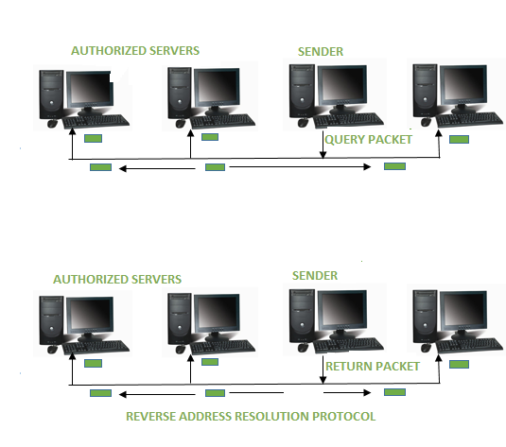
RARP
Difference between ARP and RARP: ARP vs RARP

4. ICMP
ICMP stands for Internet Control Message Protocol. ICMP is a part of IP protocol suite. ICMP is an error reporting and network diagnostic protocol. Feedback in the network is reported to the designated host. Meanwhile, if any kind of error occur it is then reported to ICMP. ICMP protocol consists of many error reporting and diagnostic messages. ICMP protocol handles various kinds of errors such as time exceeded, redirection, source quench, destination unreachable, parameter problems etc. The messages in ICMP are divided into two types. They are given below:
- Error Message: Error message states about the issues or problems that are faced by the host or routers during processing of IP packet.
- Query Message: Query messages are used by the host in order to get information from a router or another host.

How Does ICMP Work?
- The main and most significant protocol in the IP suite is called ICMP. However, unlike TCP and UDP, ICMP is a connectionless protocol, meaning it doesn’t require a connection to be established with the target device in order to transmit a message.
- TCP and ICMP operate differently from one another; TCP is a connection-oriented protocol, while ICMP operates without a connection. Every time a connection is made prior to a message being sent, a TCP Handshake is required of both devices.
- Datagrams including an IP header containing ICMP data are used to transmit ICMP packets. An independent data item like a packet is comparable to an ICMP datagram.
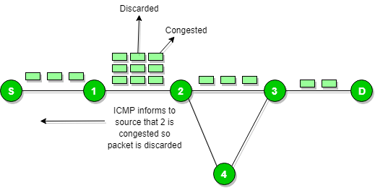
ICMP

5. IGMP
IGMP stands for Internet Group Message Protocol. IGMP is a multicasting communication protocol. It utilizes the resources efficiently while broadcasting the messages and data packets. IGMP is also a protocol used by TCP/IP. Other hosts connected in the network and routers makes use of IGMP for multicasting communication that have IP networks. In many networks multicast routers are used in order to transmit the messages to all the nodes. Multicast routers therefore receives large number of packets that needs to be sent. But to broadcast this packets is difficult as it would increase the overall network load. Therefore IGMP helps the multicast routers by addressing them while broadcasting. As multicast communication consists of more than one senders and receivers the Internet Group Message Protocol is majorly used in various applications such as streaming media, web conference tools, games, etc.

How Does IGMP Work?
- Devices that can support dynamic multicasting and multicast groups can use IGMP.
- The host has the ability to join or exit the multicast group using these devices. It is also possible to add and remove customers from the group using these devices.
- The host and local multicast router use this communication protocol. Upon creation of a multicast group, the packet’s destination IP address is changed to the multicast group address, which falls inside the class D IP address range.
Internet Protocol
Internet Protocols are a set of rules that governs the communication and exchange of data over the internet. Both the sender and receiver should follow the same protocols in order to communicate the data. In order to understand it better, let’s take an example of a language. Any language has its own set of vocabulary and grammar which we need to know if we want to communicate in that language. Similarly, over the internet whenever we access a website or exchange some data with another device then these processes are governed by a set of rules called the internet protocols.

Working of Internet Protocol
The internet and many other data networks work by organizing data into small pieces called packets. Each large data sent between two network devices is divided into smaller packets by the underlying hardware and software. Each network protocol defines the rules for how its data packets must be organized in specific ways according to the protocols the network supports.

Need of Protocols
It may be that the sender and receiver of data are parts of different networks, located in different parts of the world having different data transfer rates. So, we need protocols to manage the flow control of data, and access control of the link being shared in the communication channel. Suppose there is a sender X who has a data transmission rate of 10 Mbps. And, there is a receiver Y who has a data receiving rate of 5Mbps. Since the rate of receiving the data is slow so some data will be lost during transmission. In order to avoid this, receiver Y needs to inform sender X about the speed mismatch so that sender X can adjust its transmission rate. Similarly, the access control decides the node which will access the link shared in the communication channel at a particular instant in time. If not the transmitted data will collide if many computers send data simultaneously through the same link resulting in the corruption or loss of data.

What is IP Addressing?
An IP address represents an Internet Protocol address. A unique address that identifies the device over the network. It is almost like a set of rules governing the structure of data sent over the Internet or through a local network. An IP address helps the Internet to distinguish between different routers, computers, and websites. It serves as a specific machine identifier in a specific network and helps to improve visual communication between source and destination.

Types of Internet Protocol
Internet Protocols are of different types having different uses. These are mentioned below:
- TCP/IP(Transmission Control Protocol/ Internet Protocol)
- SMTP(Simple Mail Transfer Protocol)
- PPP(Point-to-Point Protocol)
- FTP (File Transfer Protocol)
- SFTP(Secure File Transfer Protocol)
- HTTP(Hyper Text Transfer Protocol)
- HTTPS(HyperText Transfer Protocol Secure)
- TELNET(Terminal Network)
- POP3(Post Office Protocol 3)
- IPv4
- IPv6
- ICMP
- UDP
- IMAP
- SSH

